Project Design Phase
Problem – Solution Fit Template

Date | 15 February 2025
Team ID
Project Name
Maximum Marks | 2 Marks

Problem – Solution Fit Template:
The HouseRent project is developed to make the house rental process simple and convenient. It helps tenants find suitable rental homes and allows property owners to list and manage their properties easily. The platform brings tenants, owners, and administrators together in one secure system, making the rental process faster and more organized.
Purpose
- Make it easy for tenants to search and book rental houses.
- Help property owners list and manage their properties online.
- Provide a secure and user-friendly platform for all users.
- Save time by reducing manual work in the rental process.
- Improve the overall rental experience by making it simple, reliable, and efficient.

Template:
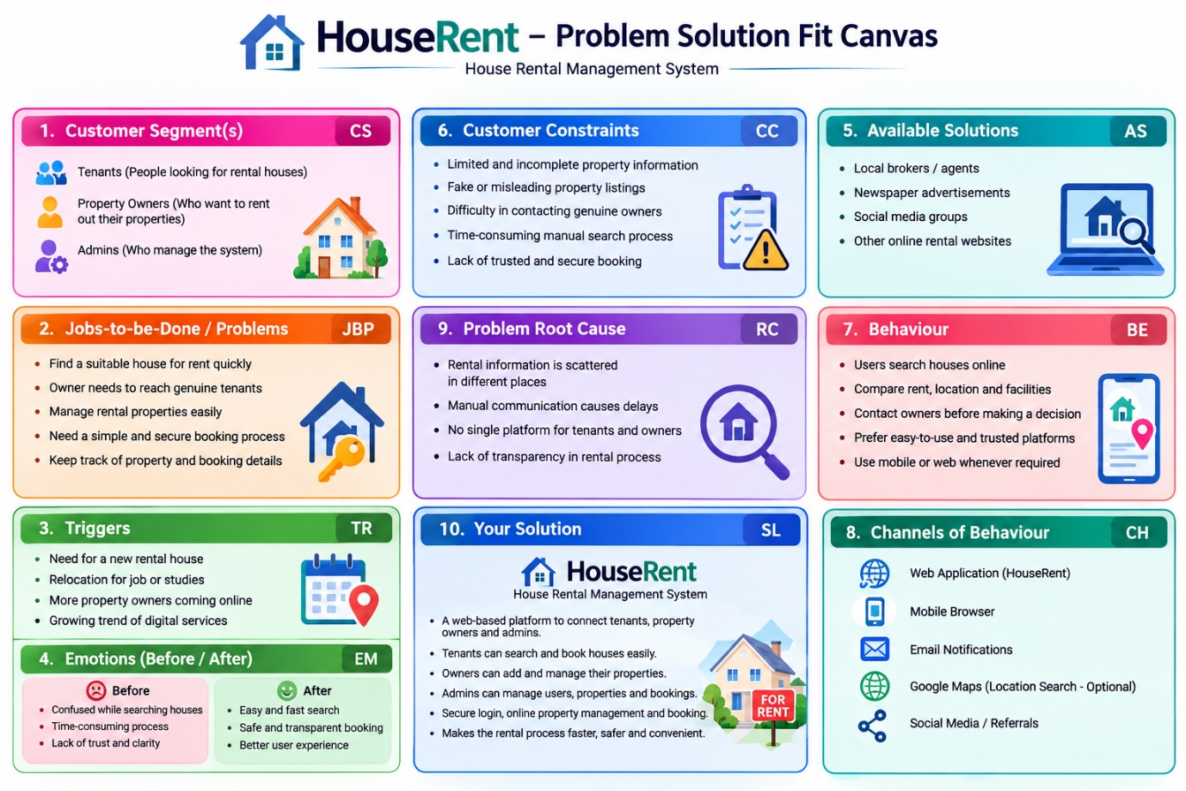

References:
- https://www.ideahackers.network/problem-solution-fit-canvas/
- https://medium.com/@epicantus/problem-solution-fit-canvas-aa3dd59cb4fe

